Create a User Dashboard

**Summary:** Using the wireframes provided below, create a user dashboard using the endpoints provided by <http://jsonplaceholder.typicode.com/>. You have the freedom to choose any approach for your Javascript, CSS, and HTML. It is recommended to pick what you are most comfortable with.

# Resources:

[Jsonplaceholder Documentation](http://jsonplaceholder.typicode.com/guide/)

# Requirements:

* Include a list of instructions or readme describing how to set up and run your application
* Page(s) should be responsive for small and large screens. The wireframes include mobile and desktop layouts.
* Wireframes are only a guideline. Layout, font-sizes, etc. do not need to be “pixel perfect”. Using a 3rd party CSS framework is totally fine!
* Create a “User List” page
  + Fetch the list of users from <http://jsonplaceholder.typicode.com/users>
  + Include a “Search” <input>. Typing in this input should automatically filter the list of users based on the following attributes:
    - name
    - username
    - email
  + Include a “Sort By” <select>. Selecting an option should automatically sort the list of users based on the following options:
    - name (default)
    - username
    - email
  + The user’s email should be a clickable link.
  + **(Optional)** If doing the optional “User Details” page, the row containing the user information should be clickable, and navigate to the “User Details” page.
* **(Optional)** “User Details” page
  + “Users” should be a link that navigates back to the “User List” page.
  + Fetch user information from **/users/{id}**
    - Example: <http://jsonplaceholder.typicode.com/users/1>
  + Create sections for the following information:
    - Contact info
      * Username
      * Email (link)
      * Phone (link)
      * Website (link, should open in a new tab)
    - Address
      * Format: **{suite} {street}, {city}, {zipcode}**
    - Company
      * Company Name
      * Company bs
      * *“Company Catch Phrase”* (italics, include quotes)
* **(Optional / Bonus)** Include a “Posts by User” section on the “User Details” page
  + After landing on the page, fetch a list of that User’s Posts from **/posts?userId={id}**
    - Example: <http://jsonplaceholder.typicode.com/posts?userId=1>
  + Display this list in a single column on small screens, and three columns on larger screens.

# Wireframes / Mockups

**User List (small screens)**

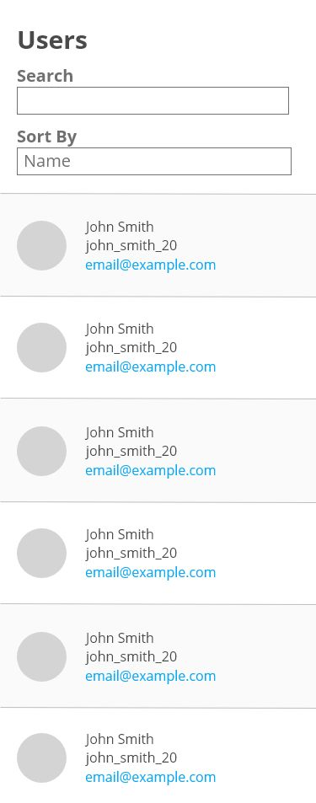

**User List (Large Screens)**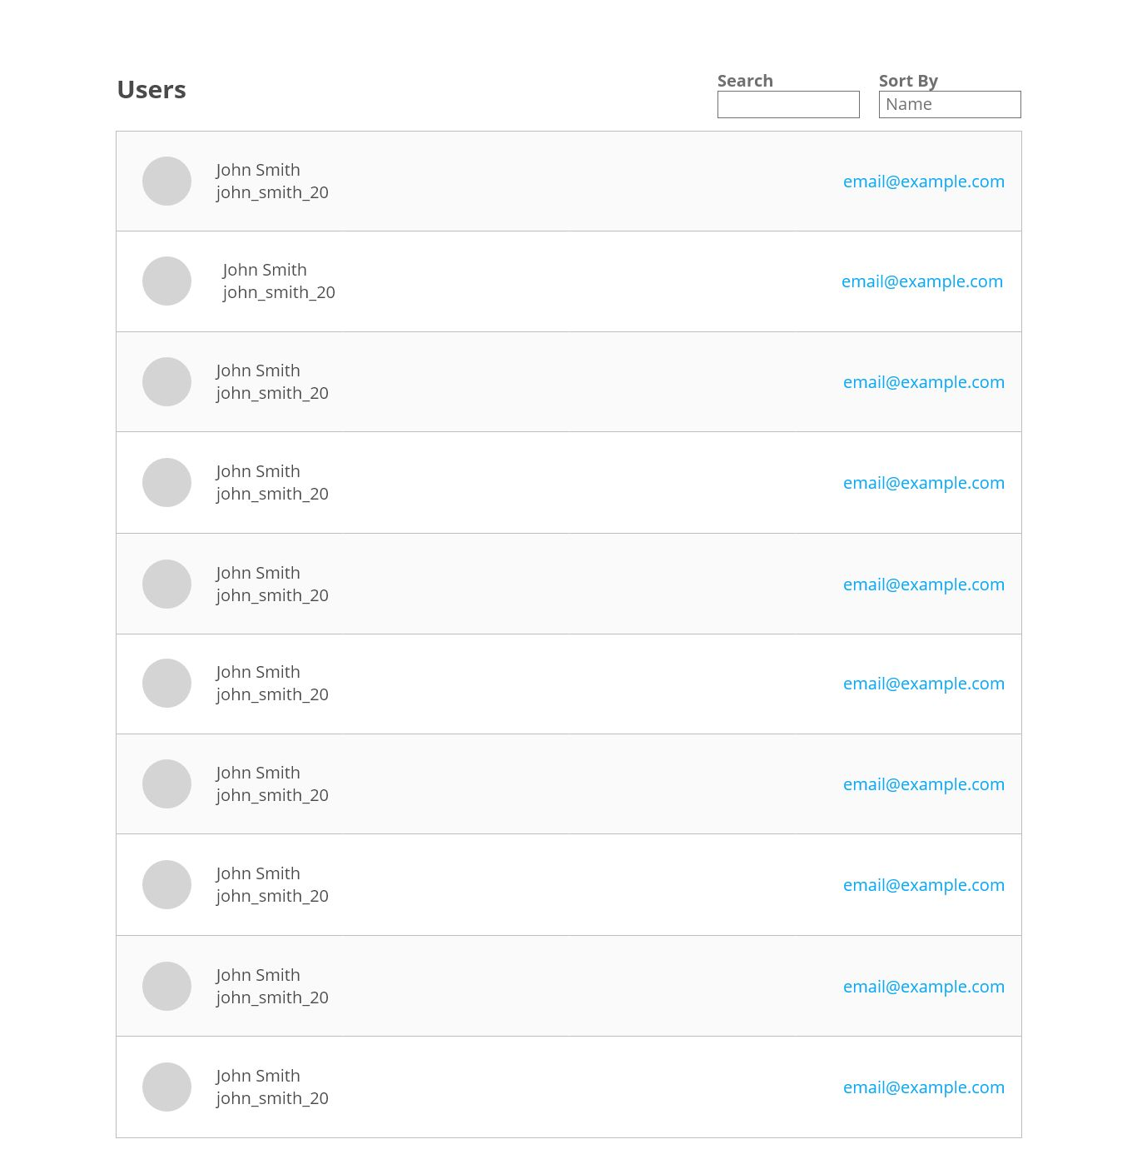

**User Details (Small Screens)  
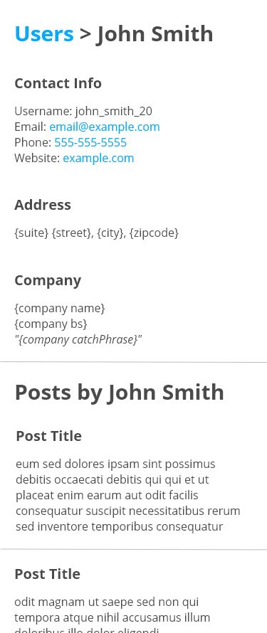**

**User Details (Large Screens)**

